|  |  |  |  |
| --- | --- | --- | --- |
| **NAME:** | Lauron, John Enrico D. | **DATE:** | 10/15/2023 |

ALGORITHM EXERCISE # 5.2

LE 5.21: **Multiplication Table (Pseudocode)**

START

1. PROMPT and GET the number of rows and columns, rows, columns
2. FOR (i = 1; i <=rows; i++) DO
   1. FOR(j = 1; j <= columns; j++) DO
      1. DISPLAY table, i * j
   2. ENDFOR
   3. DISPLAY new line
3. ENDFOR

END

LE 5.21: **Multiplication Table (Flowchart)**

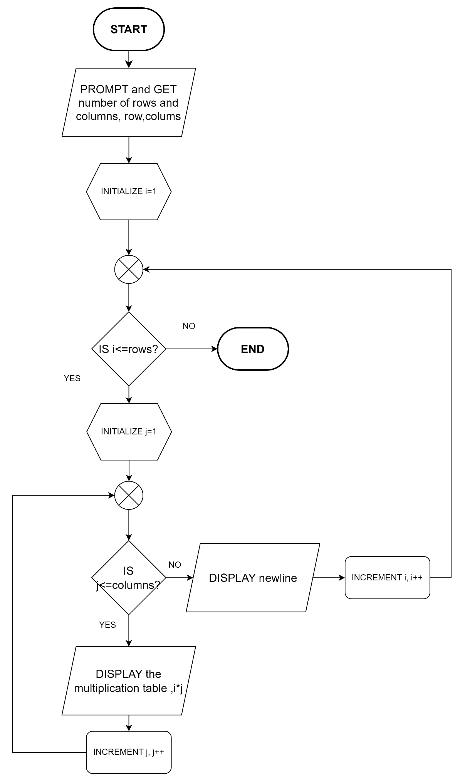

LE 5.22: **Pyramid (Pseudocode)**

START

1. PROMPT and GET the value for N, num
2. FOR (i = 1; i <=rum; i++) DO
   1. FOR(j = 1; j <= num; j++) DO
      1. IF (i + j – num >= 1) THEN
         1. DISPLAY numbers in ascending order, i + j - num
      2. ELSE
         1. DISPLAY space
      3. ENDIF
   2. ENDFOR
   3. FOR (k = 1; k <i ;k++) THEN
      1. DISPLAY numbers in descending order, i - k
   4. ENDFOR
   5. DISPLAY newline
3. ENDFOR

END

LE 5.23: **Fibonacci Sequence (Pseudocode)**

START

1. INITIALIZE term1 = 1, term2 = 2
2. PROMPT and GET limit of Fibonacci sequence, limit
3. DISPLAY Fibonacci sequence:
4. FOR (i = 1,i <= limit; i++)
   1. DISPLAY term1
   2. CALCULATE nextTerm, nextTerm = term1 + term2;
   3. CALCULATE term1, term1 = term2
   4. CALCULATE term2, term2 = nextTerm
5. ENDFOR

END

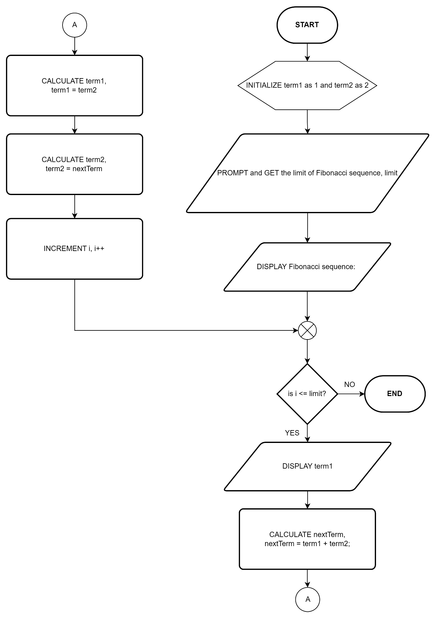LE 5.23: **Fibonacci Sequence (Flowchart)**